|  |  |  |  |  |
| --- | --- | --- | --- | --- |
|  |  | Name-Ishant Chauhan Sap id-590028602  C programming 100 days of code  1st code |  | Event subtitle |

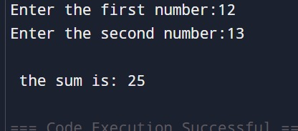

|  |  |  |  |  |
| --- | --- | --- | --- | --- |
| Magnifying glassBar chartUser**any fool will write code that computer understand,programmers write code that humans can understand."**— **Martin Fowler** (Chief Scientist, software developer, and author) |  |  |  | “Insert a quote here”  - Quote source - |